# My Team Manager



# Team x

## Next Match:

## Date: Team Y

Away/Home

Cup/Friendly Match/League



## Add new match



Home



Roster

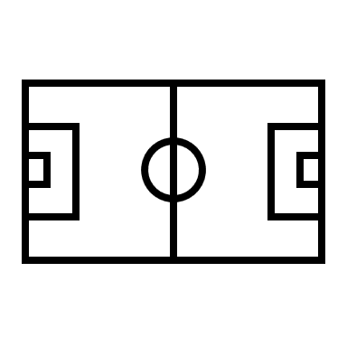

Matches



Trainings

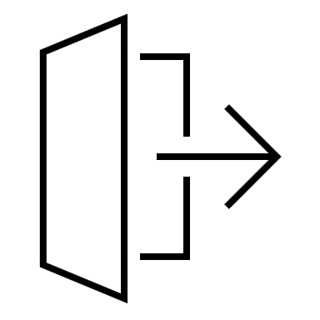

Logout

## Next Training:

## Uhr



## Add new training

## Statistics:

0 Pts



## Goals scored

## Goals conceded

0

0

# My Team Manager



# Team x



Home



Roster



Matches



Trainings



Logout

Players

Add player

|  |  |  |  |  |  |
| --- | --- | --- | --- | --- | --- |
| ID | Last name | Name | Role | Shirt-Number |  |
| 1 | Last name 1 | Name 1 | Role X | Number X | Edit|Delete |
| 2 | Last name 2 | Name 2 | Role X | Number X | Edit|Delete |
| … |  |  |  |  |  |

# My Team Manager



# Team x



Home



Roster



Matches



Trainings



Logout

Player X

Last name:

Name:

Role:

Shirt-number